Weather sensors with OSHW micro-controllers
Connectivity and circuit-board possibilities

Introduction
We are looking at setting up some basic circuit board connectivity for weather sensors. Since temperature (i.e. DS18B20), humidity (DHT11/22), pressure (BMP180) are very widely covered by online tutorials, and have several open sourced circuit boards available for perousing and PCB making (for example see Sparkfun, 2017), we will concentrate on external sensors, namely rain gauge, wind speed and velocity. Luckily, those three types of sensors, in their simplest incarnations are all reed switch based. A reed switch is a set of two connector bits that are touching each other all the time, unless in the proximity of a magnetic field. Bringing a magnet in the proximity of the reed switch, disconnects the two parts and opens the circuit, thus interrupting power. In the case of external weather sensors, the sensor is a moving part and carries a magnet inside. The wind velocity sensor counts how many turns per amount of time for example. Each time the moving part goes above a reed switch, a signal is sent inside the microcontroller, the number of signals are recorded within the micro-controller by an always listening sub-system called an IRQ (Interrupted Request), a hardware signal sent to the processor that temporarily stops a running program and allows a special program, an interrupt handler, to run instead. The program inside the micro-controller allocates an IRQ function to the PIN to which the sensor reed switch is connected.

The wind direction is different since it is a flower of 8 or 16 reed switches and the internal circuit board of the sensor sends a step-based power strength, which is giving certain values proportional to the wind direction.

The rain gauge is a simple counter, each IRQ is a volume of rainfall received in the tipping bucket, which is proportional to the height of rainfall (mm) in function of the surface area of the rain gauge and the time elapsed.

Arduino and raingauge
Arduino can enable IRQs on its digital pins. The function digitalPinToInterrupt() permits to enable the connection of the pin to the interrupt process. The function attachInterrupt(), actually sets what is happening when the IRQ is triggered (power up: rising, power down: falling) and received at the pin number. Often a function is triggered to accumulate a count of actions (e.g. reed switch clicks in our case).

Simple case: reed switch connection
In this case, the power is given to the Arduino Nano through the 5V VIN pin and the GND round pin. On the way, the reed switch of the rain gauge (or of the anemometer) is plugged from pin D2 to pin GND.

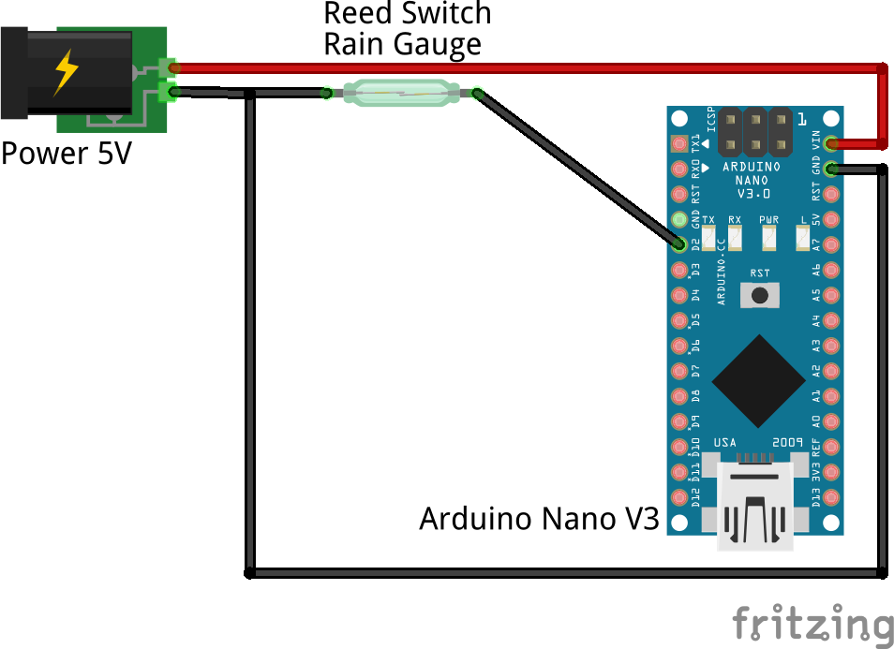
Figure 1: Connecting a reed switch to Arduino

The corresponding Arduino code is like this:

//Set PIN 2 as data input pulled up
pinMode(2, INPUT_PULLUP);
//Attach IRQ to PIN 2 and tells it to run function addRain()
attachInterrupt (digitalPinToInterrupt(2), addRain, FALLING);
//Function addRain() adds to the daily tip count
volatile tipToday;
addRain(){
tipToday+=1;
}

The reality of working in less than optimal conditions concerning the power supplies makes this case a less workable set up. Power supplies are rarely controlled and precise.

IRQ Debouncing

IRQs are sometimes sensitive to unreliable power input, thus triggering when no signal is sent (i.e. rain is falling in a clear sky day). To remedy to this, hardware debouncing is required by absorbing power input fluctuations before it influences the IRQ. An example of such setup is found below.

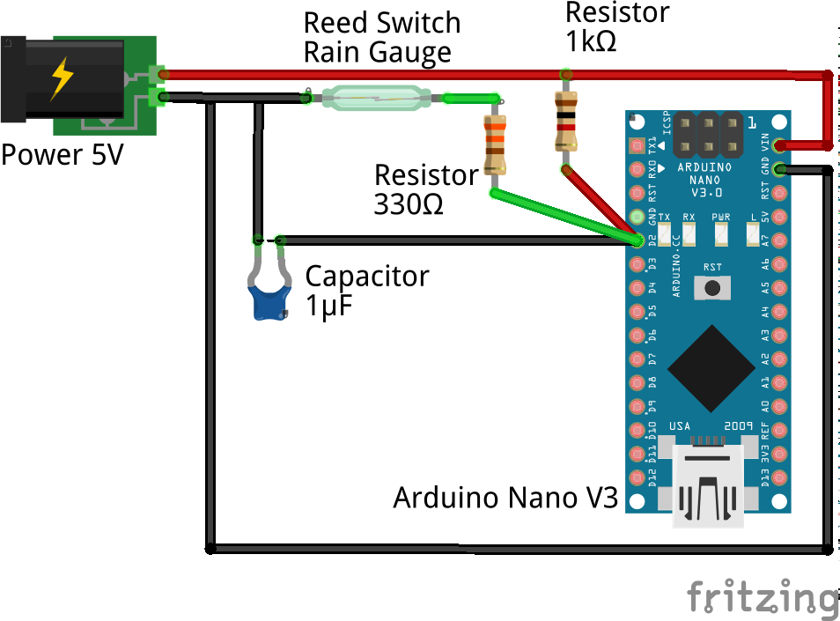
Figure 2: Debouncing a reed switch with 0.1uF (adapted from MySensors, 2017)

The rain gauge is connected to the Pin D2, which is setup as an IRQ in the Arduino code.

//Set PIN 2 as data input
pinMode(2, INPUT);
//Attach IRQ to PIN 2 and tells it to run function addRain()
attachInterrupt (digitalPinToInterrupt(2), addRain, FALLING);
//Function addRain() adds to the daily tip count
volatile tipToday;
addRain(){
tipToday+=1;
}

Miser (2017) mentioned that a 1 uF capacitor between the signal and ground is a solution to the Sparkfun weather shield phantom rain. Looking at the Sparkfun Weather Shield schematics, we find that though the resistors are set up, no capacitor is available. Thus there is no signal debouncing.
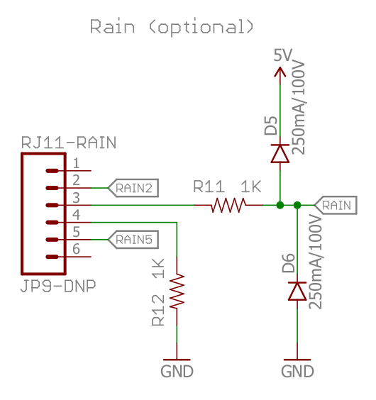
Figure 3: Raingauge RJ11 connection schematics from Sparkfun website.

Field set up #1: jump the reed switch
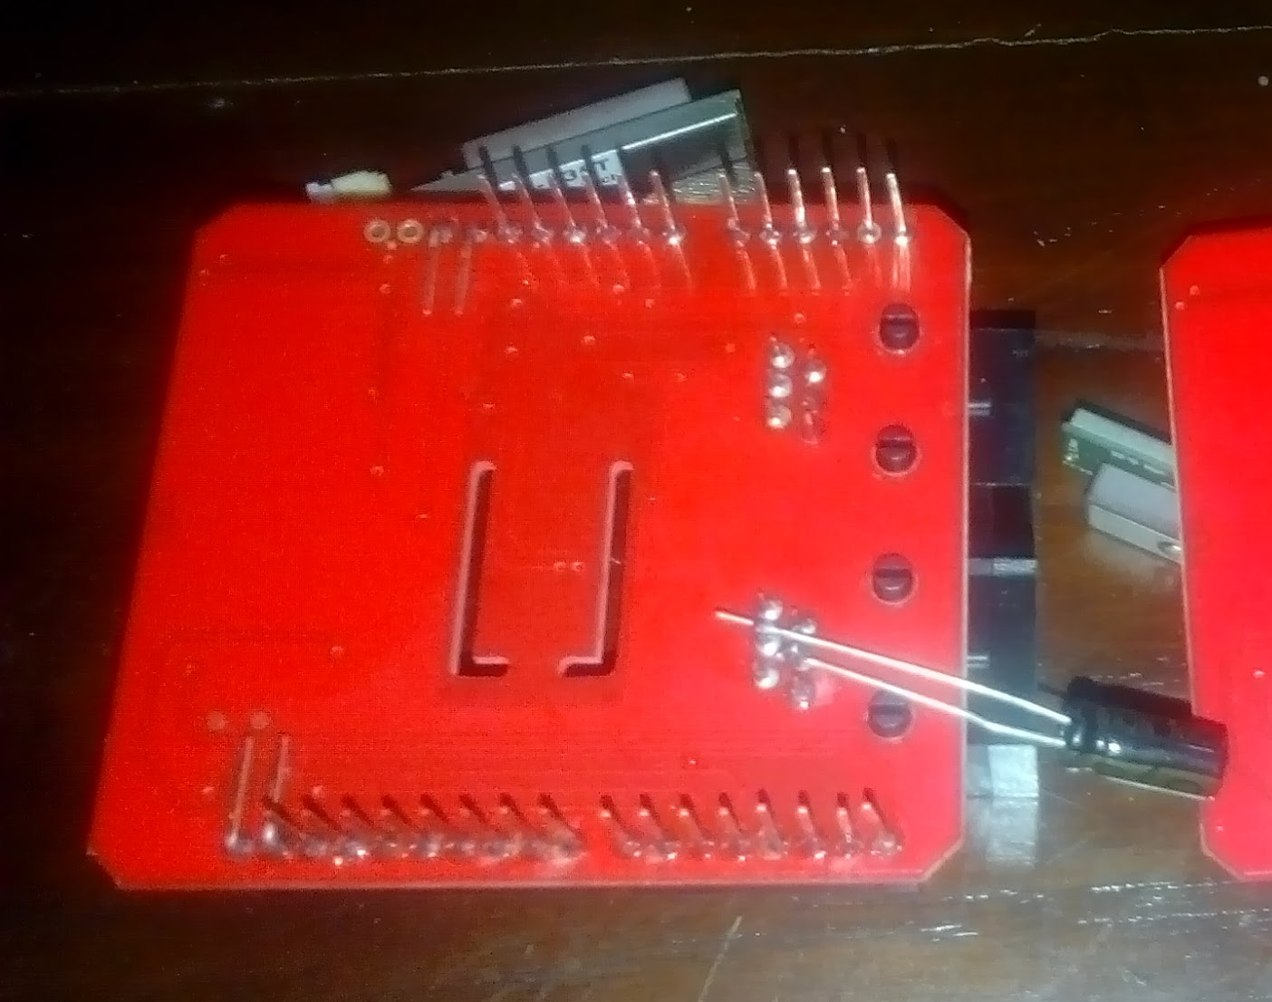
Figure 4: Jumping the reed switch with 1nF electrolytic capacitor

This setup reported apparently well for 3 days, initially leading us to think it was a progress. We will have to determine if the capacitor was overloaded or if it was just 3 days of cloudy conditions where no solar charging overload happened.

Field setup #2: Debounce on Pin D2
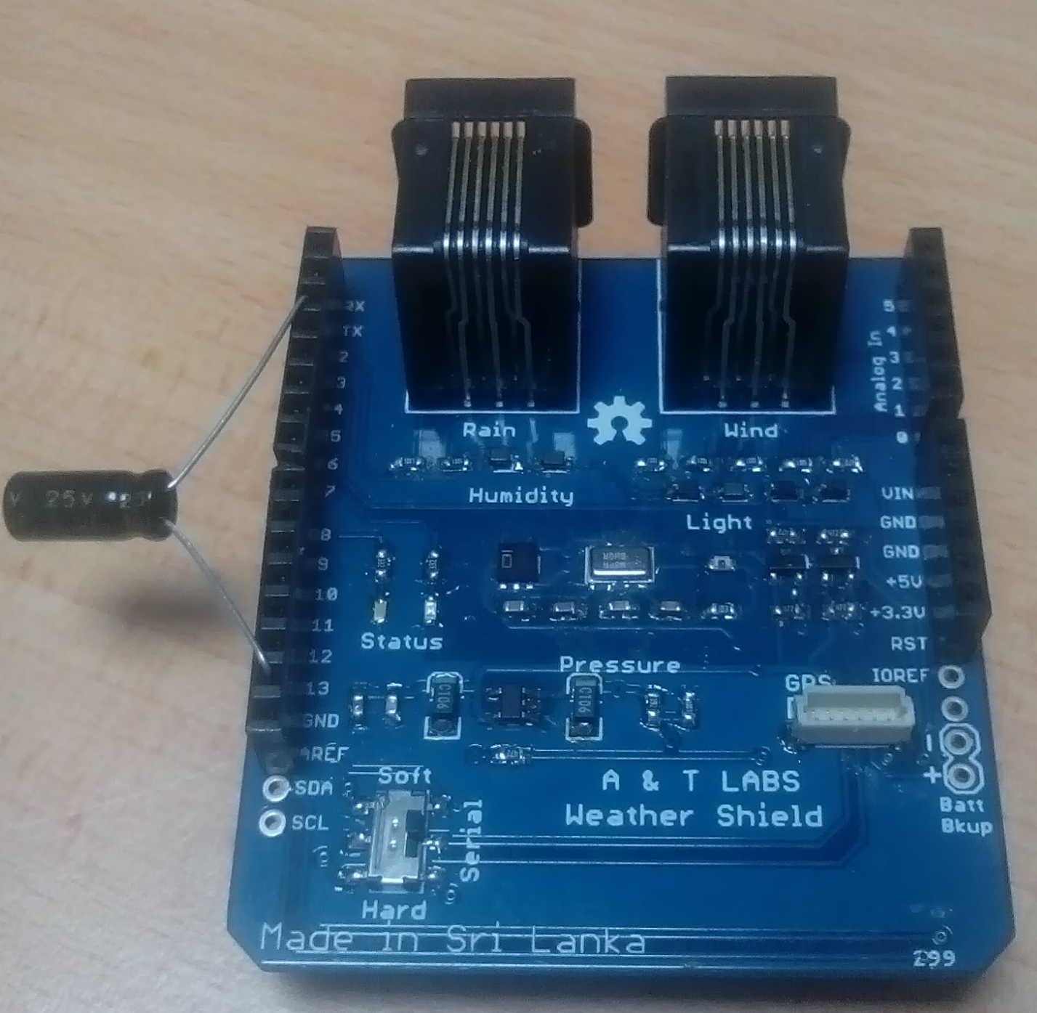
Figure 5: Debounce on Pin D2 (Rain IRQ)

After the failing of the Field setup #1, not knowing yet if it was a overloading of the capacitor (i.e. a good location on the board but a too small value) or not the right place to debounce effectively, we reassessed the circuit and looked for another potential bypass location to set up the capacitor. This time, using the IRQ pin D2 receiving the FALLING signal from the reed switch.

ESP8266 variation
The ESP8266 can be frugal in energy consumption if the WiFi onboard is switched off, around 50mA. It can be programmed within the Arduino IDE with the same coding language. Literally speaking, the connectivity is identical to an Arduino, though the programming needs to care for few different things.

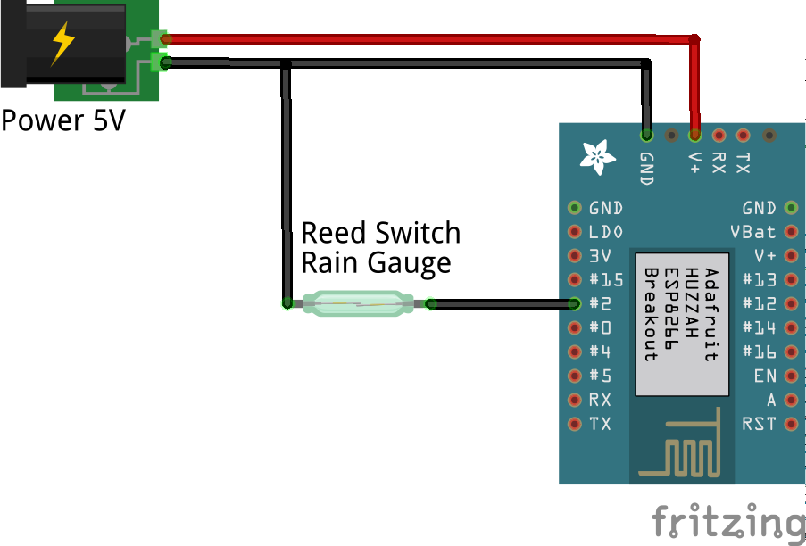
Figure 3: ESP8266 connected to a reed switch

The following LUA code permits to count the number of tips (Benlo, 2017). The IRQ is triggered on GPIO 02 when the power transitions from HIGH to LOW. The interrupts calls a counter function quoted below. The delay timer makes sure that any secondary pulse within 250ms will be discarded.

-- Count pulses on GPIO2
count = 0
delay = 0
gpio.mode(9,gpio.INT)
function counter(level)
x = tmr.now()
if x > delay then
delay = tmr.now()+250000
count = count + 1
end
end
gpio.trig(9, "down",counter)

References
Benlo, 2017. ESP8266 rain gauge. http://benlo.com/esp8266/esp8266Projects.html#rain
Miser, 2017. ESP8266 weather final test step 2-2. https://www.miser-tech.com/2017/08/esp8266-weather-final-test-step-2-2/
MySensors, 2017. Debouncing a reed switch. https://www.mysensors.org/build/rain
Sparkfun, 2017. Weather Shield Schematic (pdf url) and circuit board files (eagle files zip url), https://cdn.sparkfun.com/datasheets/Dev/Arduino/Shields/Weather%20Shield_V12.pdf
https://cdn.sparkfun.com/datasheets/Dev/Arduino/Shields/Weather%20Shield_V12.zip

